**Supplemental Material for**Association between precipitation events, drought, and animal operations with Salmonella infections in the Southwest US, 2009–2021

**Submitted to One Health, 2024**

**Corresponding Author Information**Erika Austhof, PhD MPHbarrette@arizona.edu

**Summary of Study**Using public health surveillance, meteorological, and farm animal census data from Arizona, Colorado, New Mexico, and counties in Utah, this ecological study aims to assess the association between precipitation and the incidence of *Salmonella* infections by county from 2009–2021 and determine how this association is modified by prior drought level and animal operations. We merged 29,350 cases of salmonellosis reported in 127/141 counties with total precipitation (inches), temperature (average °F), Palmer Drought Severity Index (PDSI, category), and animal census data (density per square mile) by week from 2009–2021. Negative binomial generalized estimating equations adjusted for temperature with a 2-week lag were used to explore the acute association between precipitation and salmonellosis with resulting Incidence Rate Ratios (IRR). We then conducted stratified analyses to explore the association with precipitation following antecedent drought level and type of animal density (per square mile) on this association.

**Data used in this study is available at the following link:** <https://github.com/austhofe/RainDroughtSalmonella>

This research compendium includes all relevant code to merge datasets in R, code used for analysis in Stata. Health data is not included in this repository as it requires a data use agreement with each state health department and is not publicly available. All other publicly available data is provided.

Table of Contents

Table S1. Case Definitions 2

Table S2. Data Sources 2

Table S3. QIC Statistics 3

Table S4. Moran’s I Statistics 3

Table S5. IRRs for USDM Stratified Analysis 4

Table S6. Full Model Results 5

Figures 7

Figure S1. Cattle Operations with Sales by County 8

Figure S2. Chicken and Poultry Operations with Sales by County 9

# Table S1. Case Definitions

|  |  |  |  |
| --- | --- | --- | --- |
| **Case Definition Year** | **Confirmed** | **Probable** | **Suspect** |
| 2017 | Isolation of *Salmonella spp.* from a clinical specimen † | Detection of *Salmonella spp.* in a clinical specimen  using a CIDT or epidemiologically linked to a confirmed or probable case | N/A |
| 2012 | Isolation of *Salmonella spp.* from a clinical specimen | A clinically compatible case that is epidemiologically linked to a confirmed case | Detection of *Salmonella spp.* from a clinical specimen using a non-culture based method |
| 2005 | Isolation of *Salmonella spp.* from a clinical specimen | A clinically compatible case that is epidemiologically linked to a confirmed case | N/A |
| 1997 | Isolation of *Salmonella spp.* from a clinical specimen | A clinically compatible case that is epidemiologically linked to a confirmed case | N/A |
| **FoodNet Case Definition** | Isolation of *Salmonella spp*. in a clinical specimen | Detection of *Salmonella spp*. in a clinical specimen using CIDT  Epidemiologically linked cases are not counted as cases | N/A |

Legend: CIDT, culture independent diagnostic test (CIDT).

* A case should not be counted as a new case if laboratory results were reported within 30 days of a previously reported infection in the same individual.

† A case should not be counted as a new case if laboratory results were reported within 365 days of a previously reported infection in the same individual. When two or more different serotypes are identified from one or more specimens from the same individual, each should be reported as a separate case.

# Table S2. Data Sources

Data Sources for analysis

* PRISM, meteorological data daily and 30-year normals
  + <https://prism.oregonstate.edu/explorer/>
* NOAA, drought severity county time series
  + <https://www.ncei.noaa.gov/access/monitoring/climate-at-a-glance/county/time-series>
* NOAA, NCEI Southern Oscillation Index
  + <https://www.ncei.noaa.gov/access/monitoring/enso/soi>
* USDM, drought severity time series
  + <https://droughtmonitor.unl.edu/dmData/Timeseries.aspx>
* USDA Animal Census, presence and density data
  + <https://www.nass.usda.gov/Data_and_Statistics/County_Data_Files/Livestock_County_Estimates/index.php>
* Köppen-Geiger climate zone, sensitivity analysis
  + Beck HE, Zimmermann NE, McVicar TR, Vergopolan N, Berg A, Wood EF. Present and future Köppen-Geiger climate classification maps at 1-km resolution. Sci Data. 2018;5(1):180214. doi:10.1038/sdata.2018.214
* US Census, land area by county
  + <https://www.census.gov/geographies/reference-files/time-series/geo/gazetteer-files.html>
* US Census, population estimates
  + <https://www.census.gov/data/datasets/time-series/demo/popest/2010s-counties-total.html>
  + <https://www.census.gov/data/tables/time-series/demo/popest/2020s-counties-total.html>

# Table S3. QIC Statistics

Pan’s quasi likelihood (QIC) metrics for determining the best model for different variable combinations. While models including county population were the best fit according to QIC, estimates were largely unstable. Therefore we chose to include total precipitation, average temperature, and PDSI in the final model (bolded and highlighted in green in the table).

|  |  |  |  |  |  |  |
| --- | --- | --- | --- | --- | --- | --- |
|  | ***p*** | **Trace** | **QIC** | **QICu** | **Estimates diverging** | **Final Chosen Model** |
| Total precipitation | 2 | 1144.299 | 82740.19 | 80455.59 |  |  |
| Average temperature | 2 | 539.708 | 75982.87 | 74907.45 |  |  |
| PDSI | 2 | 1160.74 | 82774.91 | 80457.43 |  |  |
| County population | 2 |  |  |  | Yes |  |
| Total precipitation and Average temperature | 3 | 534.911 | 75803.66 | 74739.84 |  |  |
| Total precipitation and PDSI | 3 | 1164.151 | 82775.22 | 80452.92 |  |  |
| Total precipitation and County population | 3 |  |  |  | Yes |  |
| Average temperature and PDSI | 3 | 547.489 | 75931.55 | 74842.57 |  |  |
| Average temperature and County population | 3 | 1600.771 | 62324.37 | 59128.83 |  |  |
| PDSI and County population | 3 |  |  |  | Yes |  |
| Total precipitation, Average temperature, and PDSI | 4 | 554.891 | 75675.35 | 74573.57 |  | Yes |
| Total precipitation, Average temperature, and County population | 4 | 1024.886 | 61336.41 | 59294.64 |  |  |
| Average temperature, PDSI, and County population | 4 | 1059.217 | 61215.78 | 59103.35 |  |  |
| Total precipitation, PDSI, Average temperature, and County population | 5 |  |  |  | Yes |  |

Legend: p, number of parameters; trace, the product of the independent and robust variance estimators; QIC, Pan’s quasi likelihood under the independence model criterion; QICu, the QIC when trace approximates an independent covariance structure and is equivalent to the number of parameters; Total precipitation, total precipitation in inches in a week; Average temperature, average temperature in °F in a week; PDSI, Palmer Drought Severity Index standardized from 0 to 20 with larger values indicating more severe drought in a month; County population, the county population from 2020 US Census estimates.

# Table S4. Moran’s I Statistics

Moran’s I statistics exploring spatial autocorrelation among counties in each state for 2019. We estimated the Moran’s I for a random sample of 4 years in each state and observed values were the same across all. Moran’s I was calculated in R using the ape package on a scale of -1 to +1. Minimal to no spatial autocorrelation is indicated by a value close to 0.

|  |  |  |  |  |
| --- | --- | --- | --- | --- |
|  | Observed | Expected | Standard Deviation | *p* |
| Arizona | -0.03 | -0.001 | 0.00 | <0.00 |
| Colorado | 0.05 | -0.001 | 0.00 | <0.00 |
| New Mexico | -0.00 | -0.001 | 0.00 | <0.00 |
| Utah | 0.03 | -0.001 | 0.00 | <0.00 |

# Table S5. IRRs for USDM Stratified Analysis

IRR and 95% CI for a one inch increase in precipitation on *Salmonella* cases at different levels of drought severity via the USDM

|  |  |
| --- | --- |
| **US Drought Monitor Category** | **IRR (95% CI)** |
| None (reference) | 1.0 (ref) |
| Abnormally dry | 1.14 (1.09, 1.19) |
| Moderate drought | 1.27 (1.22, 1.34) |
| Severe drought | 1.13 (1.07, 1.19) |
| Extreme drought | 0.93 (0.87, 0.99) |
| Exceptional drought | 0.73 (0.64, 0.82) |

# Table S6. Full Model Results

The following table provides estimates (IRR (95% CI)) for the analysis exploring the effect of precipitation on *Salmonella* cases stratified by different spatial scales, restricting to certain years, and adjusting for Southern Oscillation Index.

|  |  |  |  |  |  |  |  |
| --- | --- | --- | --- | --- | --- | --- | --- |
|  | **Precipitation (crude)** | **Precipitation stratified by antecedent PDSI** | | | | | |
| **Extremely wet** | **Very wet** | **Moderately wet** | **Moderate drought** | **Severe drought** | **Extreme drought** |
| **Multivariate model (all cases)** | 1.02 (1.00, 1.04) | 1.13 (1.00, 1.27) | 0.94 (0.85, 1.04) | 1.07 (0.99, 1.14) | 1.22 (1.17, 1.28) | 1.16 (1.10, 1.22) | 0.88 (0.83, 0.93) |
|  |  |  |  |  |  |  |  |
| **Confirmed Cases only** | 0.99 (0.97, 1.02) | 2.31 (2.10, 2.53) | 1.95 (1.78, 2.13) | 1.54 (1.43, 1.66) | 1.11 (1.04, 1.19) | 1.14 (1.06, 1.23) | 1.03 (0.96, 1.10) |
|  |  |  |  |  |  |  |  |
| **Multivariate model (all cases), different lags** |  |  |  |  |  |  |  |
| Lag 1 | 1.03 (1.01, 1.04) | 1.15 (1.03, 1.29) | 1.07 (0.97, 1.17) | 1.06 (0.99, 1.13) | 1.19 (1.13, 1.24) | 1.13 (1.07, 1.19) | 0.87 (0.82, 0.93) |
| Lag 3 | 1.02 (1.00, 1.03) | 1.09 (0.97, 1.23) | 1.09 (0.99, 1.19) | 1.04 (0.97, 1.11) | 1.17 (1.11, 1.22) | 1.08 (1.03, 1.14) | 0.89 (0.84, 0.94) |
|  |  |  |  |  |  |  |  |
| **State** |  |  |  |  |  |  |  |
| Arizona | 1.03 (1.01, 1.04) | 0.53 (0.15, 1.94) | 0.72 (0.53, 0.98) | 1.04 (0.96, 1.12) | 1.07 (1.01, 1.12) | 1.08 (1.02, 1.15) | 0.98 (0.91, 1.06) |
| Colorado | 0.98 (0.95, 1.02) | 1.97 (1.76, 2.19) | 1.41 (1.26, 1.59) | 1.31 (1.19, 1.44) | 1.43 (1.3, 1.57) | 1.24 (1.12, 1.37) | 0.87 (0.79, 0.96) |
| New Mexico | 0.98 (0.93, 1.03) | 0.29 (0.09, 0.88) | 0.65 (0.46, 0.91) | 0.78 (0.63, 0.96) | 1.05 (0.94, 1.17) | 0.92 (0.82, 1.04) | 0.86 (0.76, 0.97) |
| Utah | 1.10 (1.04, 1.17) | 0.52 (0.31, 0.86) | 1.48 (1.09, 2.01) | 0.96 (0.70, 1.31) | 1.50 (1.3, 1.73) | 1.44 (1.25, 1.66) | 1.30 (1.1, 1.53) |
|  |  |  |  |  |  |  |  |
| **Climate Zone** |  |  |  |  |  |  |  |
| B | 1.02 (1.01, 1.04) | 0.96 (0.82, 1.11) | 0.86 ( 0.77, 0.97) | 1.05 (0.97, 1.13) | 1.18 (1.12, 1.24) | 1.14 (1.08, 1.20) | 0.91 (0.85, 0.97) |
| D | 1.02 (0.97, 1.07) | 2.05 (1.76, 2.39) | 1.65 (1.38, 1.96) | 1.34 (1.17, 1.53) | 1.60 (1.42, 1.81) | 1.32 (1.16, 1.50) | 0.84 (0.74, 0.95) |
|  |  |  |  |  |  |  |  |
| **Urbanicity** |  |  |  |  |  |  |  |
| Urban | 1.01 (1, 1.03) | 1.12 (1.00, 1.25) | 0.94 (0.85, 1.04) | 1.04 (0.98, 1.11) | 1.19 (1.14, 1.24) | 1.14 (1.08, 1.19) | 0.86 (0.81, 0.91) |
| Rural | 1.03 (0.93, 1.14) | 0.42 (0.21, 0.86) | 0.36 (0.19, 0.69) | 0.76 (0.54, 1.06) | 1.21 (0.98, 1.48) | 1.06 (0.86, 1.32) | 1.09 (0.9, 1.33) |
|  |  |  |  |  |  |  |  |
| **NCHS Urban-Rural Classification Scheme** |  |  |  |  |  |  |  |
| Large central metro (>1 million or more population, contain largest city in MSA) | 1.00 (0.98, 1.02) | 0.78 (0.64, 0.94) | 0.82 (0.71, 0.95) | 0.95 (0.88, 1.02) | 1.01 (0.98, 1.05) | 1.01 (0.97, 1.06) | 0.93 (0.88, 0.99) |
| Large fringe metro (>1 million adjacent to largest city) | 0.99 (0.94, 1.03) | 0.89 (0.78, 1.03) | 0.85 (0.73, 0.99) | 1.01 (0.90, 1.14) | 0.98 (0.89, 1.09) | 0.98 (0.87, 1.10) | 0.84 (0.73, 0.97) |
| Medium metro (250,000 to 999,999 population) | 1.01 (0.98, 1.04) | 0.87 (0.73, 1.03) | 0.89 (0.76, 1.04) | 1.03 (0.93, 1.14) | 1.04 (0.97, 1.12) | 0.97 (0.90, 1.05) | 0.91 (0.84, 0.99) |
| Small metro (<250,000 population) | 1.06 (0.99, 1.12) | 1.26 (0.83, 1.91) | 0.95 (0.71, 1.27) | 0.91 (0.76, 1.09) | 1.13 (1.01, 1.26) | 1.08 (0.96, 1.22) | 1.06 (0.94, 1.19) |
| Micropolitan (1 urban cluster of 10,000 to 49,999 population) | 1.05 (0.99, 1.12) | 0.76 (0.52, 1.09) | 0.91 (0.69, 1.18) | 0.80 (0.67, 0.97) | 1.10 (0.98, 1.24) | 0.99 (0.88, 1.13) | 1.00 (0.89, 1.12) |
| Non-core | 1.07 (0.95, 1.19) | 0.62 (0.30, 1.27) | 1.03 (0.71, 1.51) | 0.68 (0.48, 0.96) | 1.11 (0.89, 1.39) | 0.97 (0.77, 1.22) | 1.08 (0.88, 1.31) |
|  |  |  |  |  |  |  |  |
| **Pre-COVID** | 1.02 (1.00, 1.04) | 1.12 (0.99, 1.26) | 0.94 (0.85, 1.04) | 1.06 (0.99, 1.13) | 1.26 (1.20, 1.32) | 1.21 (1.14, 1.27) | 0.94 (0.88, 1.00) |
|  |  |  |  |  |  |  |  |
| **Adjusting for SOI** | 1.02 (0.99, 1.04) | 1.12 (0.99, 1.27) | 0.94 (0.84, 1.04) | 1.06 (0.99, 1.14) | 1.22 (1.16, 1.28) | 1.15 (1.09, 1.22) | 0.88 (0.83, 0.93) |
|  |  |  |  |  |  |  |  |
| **Counties with Farm Operations with Sales (USDA)** |  |  |  |  |  |  |  |
| Cattle | 1.37 (1.31, 1.43) | 1.58 (1.40, 1.79) | 1.31 (1.17, 1.46) | 1.46 (1.35, 1.58) | 1.63 (1.54, 1.73) | 1.54 (1.45, 1.64) | 1.16 (1.08, 1.25) |
| Chicken and Poultry | 2.71 (2.55, 2.88) | 3.12 (2.76, 3.53) | 2.60 (2.31, 2.91) | 2.83 (2.60, 3.09) | 3.21 (2.99, 3.45) | 3.06 (2.84, 3.3) | 2.31 (2.13, 2.51) |
|  |  |  |  |  |  |  |  |
| **Different Exposure** |  |  |  |  |  |  |  |
| Heavy precipitation, total precipitation in a week over a 30 year normal | 1.08 (1.04, 1.13) | 1.20 (1.07, 1.36) | 1.00 (0.90, 1.12) | 1.14 (1.06, 1.23) | 1.3 (1.23, 1.38) | 1.23 (1.16, 1.31) | 0.94 (0.87, 1) |
| Total precipitation above the 95th percentile | 1.06 (1.03, 1.1) | 1.17 (1.04, 1.32) | 0.98 (0.88, 1.09) | 1.12 (1.04, 1.20) | 1.27 (1.21, 1.35) | 1.21 (1.14, 1.28) | 0.92 (0.86, 0.98) |
| Total precipitation above the 99th percentile | 1.04 (0.98, 1.12) | 1.16 (1.01, 1.32) | 0.96 (0.85, 1.09) | 1.09 (1.00, 1.20) | 1.25 (1.15, 1.35) | 1.18 (1.09, 1.28) | 0.9 (0.82, 0.98) |

Legend: NCHS, National Center for Health Statistics; PDSI, Palmer Drought Severity Index; SOI, Southern Oscillation Index; USDA, United States Department of Agriculture

# Figures

The following include maps of farm operations with sales by county for Arizona, Colorado, New Mexico, and Utah from the 2017 USDA Animal Census for cattle, chicken and poultry. USDA defines a farm operations with sales as any place that produced and sold—or normally would have produced and sold—at least $1,000 of agricultural products during a given year. USDA uses acres of crops and head of livestock to determine if a place with sales less than $1,000 could normally produce and sell at least that amount.

Figure S1. Cattle Operations with Sales by County

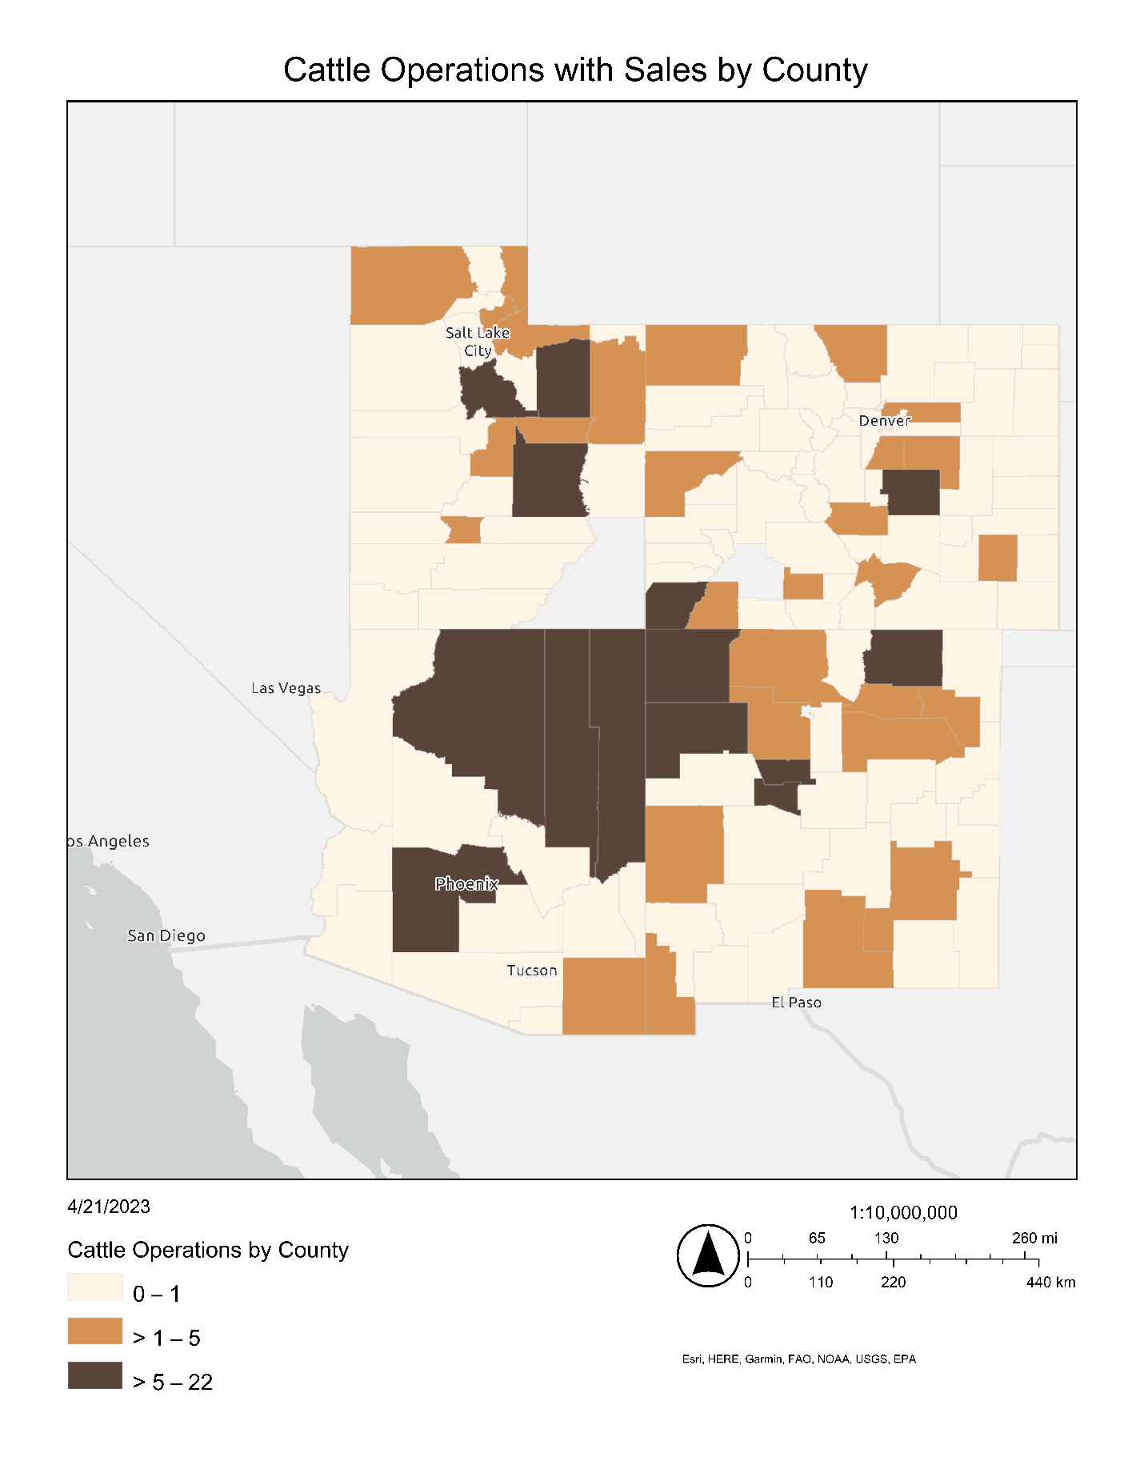

Figure S2. Chicken and Poultry Operations with Sales by County

